Draft Article: The Backyard Orchard
Submitted by Garreta Kipp, March 20, 2019

The Backyard Orchard.
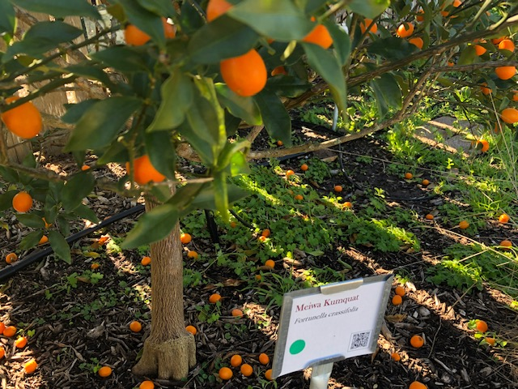
What can be better than harvesting colorful, fresh and tasty fruit from your own backyard! If the anticipation and excitement of growing fruit trees, berries and grapes appeals to you, the FBMG backyard demonstration orchard is a must for you to see. This compact orchard offers a realistic example of what you can achieve in your own backyard space. One key to success will be to start with a selection of fruit tree varieties with proven track-records of growing well in Fort Bend County, and there are many varieties to choose from. The Backyard Orchard (BYO) features 18 of them for you to see, as well as red grapes and berries!
Your compact orchard will benefit from an aesthetic layout that supports healthy plant growth and easy maintenance. Plant groupings and pruning techniques, which will vary by tree type, will also be important. The BYO includes a vibrant grouping of citrus, peach and pear trees as well as espaliered grapes and figs. All are specifically pruned to promote optimal tree health and fruit production. If you are looking for fruit orchard inspiration and “how-to” examples, seasonal visits to the BYO will encourage you to begin an orchard of your own.
The pleasure of fresh-picked fruit really can be yours. Why not visit our Backyard Orchard to see for yourself!

