Demonstration Compost Garden Article
Authored by Garreta Kipp
November 14, 2019

Create Virtual Gold for your Garden by Composting!
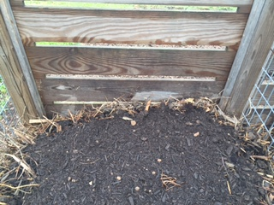
A visit to an out-of-the-way compost pile is not what most of us would think to do when we visit a series of gardens. Most often, we feel immediately drawn to beds of vibrant plants that offer a variety of structures, leaf shapes, flowers, and fragrances. We seldom seek out the compost pile which, in its own special way, is actually a garden, too! While it has no above-ground glamour to attract our attention, the compost garden creates underground treasure that is like gold to plants. For plant-lovers who want the deep pleasure of growing and maintaining gardens that are remarkably vigorous, healthy and less prone to disease and pest problems, the relatively small amount of time spent developing the home compost garden is well worth the blessings of its rich rewards!
Compost in bin
So, you may ask, what is compost and what makes it so valuable to plants? The answer is easy enough – compost is what we call the sweet, earthy smelling, crumbly material created when organic matter such as fresh grass clippings, dead leaves and fallen twigs decompose over time. Oxygen from air, water from rain, insects and soil micro-organisms are all essential contributors to this natural process. Imagine the rich compost you would find on the soft floor of a deciduous forest. It would be nutrient-rich and teeming with microscopic organisms that vitalize the soil of the forest. Our Demonstration Compost Garden offers a perfect example of how this process can be mimicked on a smaller scale, and you can do the same in your home garden!
When you visit our demonstration gardens, you will find the compost area conveniently located near a garden that thrives when composted is added -- the Vegetable Garden! We have built several bins to keep our compost piles discrete and tidy. To generate compost, each bin is filled until approximately ¾ full with a mix of 30% fresh green materials from plant trimmings (weeds and any diseased materials are not allowed), and 70% dry material – primarily dry leaves and twigs that have been cut to a small size. (It should be noted that vegetable scraps, crushed egg shells and coffee grounds can also be used as green materials.)
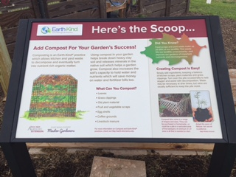
Once the materials are in the bin, proper amounts of water and a proper amount of air exposure will promote microbial activity and the natural generation of heat within the pile. In this heated environment, materials will decompose to produce compost any gardener would be proud to use. In our garden, the entire process takes between three and four months. When one bin is full, another is started so that compost is continually being made and our other gardens continually benefit from a regular compost dressing.
Informational Sign in Composting Area
There are a few additional steps to our composting process. To promote microbial action, a few shovels of composted manure is added to our piles about four times each year. This is not a requirement for a home compost pile, but it does help inoculate the pile with additional microbes to encourage and promote faster decomposition of organic matter. We also turn our compost pile occasionally to ensure optimal exposure of materials to oxygen. Materials will decompose if the pile is not turned, but the composting process will take much longer.
Composing can sometimes present challenges, but they can easily be addressed. Too much water can lead to a smelly pile. Adding more dry material to the mix (which could include the addition of shredded paper or cardboard) will help absorb the extra damp. Too much fresh green material (which means too much nitrogen) can also lead to a smelly pile. Again, the addition of more dry material will rebalance the mix and solve the problem. If a pile is to dry, or if there is not enough oxygen exposure, the composting process will be very slow.
In summary, compost success depends on properly proportioned green/dry materials, an appropriate amount of moisture and air to create an environment where microbes can go to work breaking down materials. As they do, heat will be generated in the interior of the pile. Our Master Gardeners measure the internal heat of our compost pile once a week using a special thermometer. Measurements between 80° and 100°let us know the pile is warming up. Microbial activity is most active when the temperature is between 100° and 130°. When the temperature is between 130° and 160°, seeds and pathogens are killed. Once the compost is complete, the pile will begin to cool off. Finished compost is sifted to remove any larger pieces of material that will need more time to decompose.
So, there you have it – the basic composting process! It can be fun, and it can be easy. With a little practice your efforts will yield virtual gold for your garden!
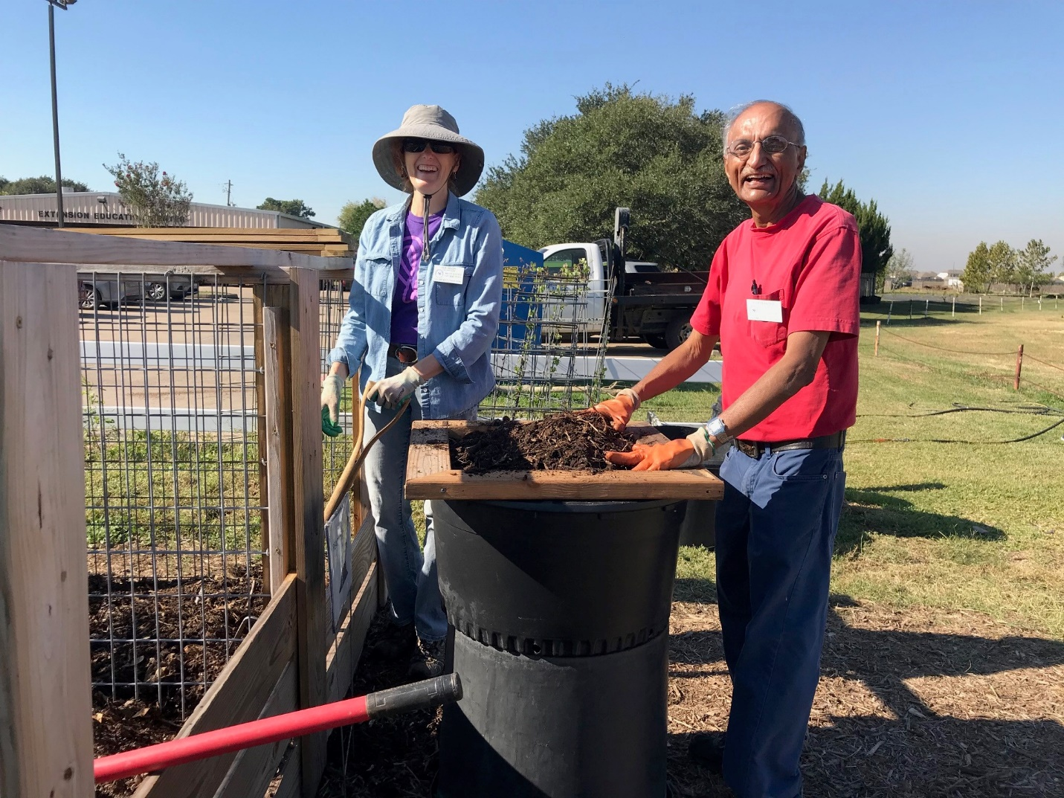
Fort Bend Master Gardeners working in composting area
We invite you to visit our Compost Garden to see just how easy it can be to create your own. While we use bins, you may want to use an open pile or purchase a compost tumbler. Regardless, the basic process will be the same and the rich rewards will be yours to claim! Happy Composting!
Suggested resources for readers:
- Texas Gardening the Natural Way by Howard Garrett
Photo credits: Julie Evett and Garreta Kipp, Fort Bend Master Gardeners

